IFRS 9 – Migration Matrix Construction

Version 0.00

|  |  |  |  |
| --- | --- | --- | --- |
| Version | Créé / Modifié par | Nature des modifications | Date |
| 0.0 | Ismail Boutaleb | Initialisation | 17/01/2018 |
|  | Ismail Boutaleb | An impact study of SME and sovereign filter on default rate is done part III.b.5. |  |

Table of contents

I. Purpose of this document 3

II. Data overview 4

III. Historical migration matrix construction 5

a. Construction methodology 5

b. Construction choices 6

1. Not rated treatment 6

2. Historical Depth and frequency 7

3. Matrix regularization 7

4. Engagement filter 7

5. Segmentation 8

IV. Matrix regularization methodology 10

a. Motivation 10

1. Definition of a regular transition matrix 10

2. Example or irregular observed matrices 10

3. Evidence of statistical incertitude 11

b. Methodology description 13

1. Default vector regularization 15

2. Migration probability regularization 17

c. Results and Impacts 17

V. Term structure default probability 23

VI. Appendix 24

a. Regularization impacts 24

VII. Bibliography 27

# Purpose of this document

IFRS 9 and EBA stress tests require historical default probability models allowing measuring TTC and PIT (stressed or forward looking) transition matrices along with term structure default probability.

This document describes the methodology used by CACIB for constructing TTC regular migration matrices, 1Y PD vector and PD term structure for each rating and maturity.

# Data overview

The available rating and default databases are:

## Internal database:

All the counterparties present in “DRPP.dbo.tbl_Engagement” which gathers all the bank engagements since June 30th, 2006. **The Forward Looking calibration of ECL parameters is done using only the internal database.**

Ratings

* 13 ratings are available A+, A, B+, B, C+, C, C-, D+, D,D-, E+, E, E- for non-default counterparties and ;
* 2 additional ratings for defaulted debtors F and Z. The definition of the default is compliant with the group Credit Agricole SA definition. For the purpose of IFRS 9 impairments and stress tests, F and Z are merged in one default absorbing state denoted F.

## S&P credit pro data base

This database gathers all S&P ratings updates and defaults since 1981. This database contains obviously more data than the internal database; however it does not represent the internal portfolio. **The S&P matrices serve to calibrate the Significant Deterioration of credit risk.**

Both databases contain the id of the issuer, its country and its sector allowing for segmentation analysis.

# Historical migration matrix construction

## Construction methodology

The migration matrices construction methodology is issued from S&P documentation 0. It is used for S&P database as the same as for the internal database.

The methodology is called the “Static Pool Methodology”, it basically looks at the initial and final states of a pool of issuers with the same risk profile and accounts for each migration from a rating to another. The default state is considered as an absorbing rating. All issuers surviving and rated at the initial date form a pool called a generation. The time difference between the final date and the initial date is called the matrix maturity.

The following parameters are retrieved from both databases:

1. Point In Time transition matrices: Available for generations selected quarterly and for different maturities going up to 20 years for S&P database;
2. Through The Cycle transition matrices, constructed as the mean over all PIT matrices weighted by the population in each generation. The higher the maturity the less generations of PIT matrices are available;
3. TTC and PIT default rates derived from the default column of the transition matrices;
4. All the above metrics could be obtained in numbers in place of rates, these serve for assessing the statistical relevance of an observed rate. As an illustration, the numbers are used for assessing likelihood in the matrix regularization process.

The TTC matrix calibration is done for IFRS 9 and the stress tests.

Implementation validation

A validation process is done to ensure the methodology implementation is compliant with S&P’s implementation. It consists in comparing the constructed matrices using S&P database with S&P’s CreditPro matrices. (See the validation file attached below). An arbitrary set of matrices has been selected. The selection aims at testing different functionalities such as selecting one or a pool of generations, different maturities, NR treatments, selecting all sectors / countries, one sector, one country or a pool of sectors.

**The validation does not disclose significant discrepancies between the constructed matrices**:

* No discrepancies for the matrices constructed with the NR included treatment (The one used for the internal database).
* Some rare discrepancies are observed with the NR excluded treatment. They are due to a monthly observation of the NR individuals, whereas S&P implementation does it daily. When the event of “a migration to NR and a migration back to being rated” occurs quickly (within a calendar month), this event is undetectable by the internal tool. It is called undetected NR. The event itself does not imply any significant interpretation on the credit quality of the counterparty nor is its impact significant.

The table below summarizes the tests run and the average discrepancy between S&P Credit pro matrix and S&P matrix constructed by the internal tool.

|  |  |  |  |  |  |  |  |  |
| --- | --- | --- | --- | --- | --- | --- | --- | --- |
| Test | Generation | Maturity | NR treatment | Sector | Country | Comparing | Average discrepancy | Comment |
| 1 | 1981 | 1 | Included | All | All | Count | 0.00 | - |
| 1 bis | 1981 | 1 | Included | All | All | Percentage | 0.05% | Rounding |
| 2 | 2003 | 10 | Included | All | All | Count | 0.00 | - |
| 3 | 1981-2015 | 1 | Included | All | All | Percentage | 0.00% | - |
| 4 | 1984 | 20 | Excluded | All | All | Count | 0.00 | - |
| 5 | 1981-2015 | 1 | Excluded | All | All | Percentage | 0.31% | Undetected NR |
| 6 | 1981-1996 | 20 | Excluded | All | All | Percentage | 1.18% | Undetected NR on long period |
| 6 bis | 1981-1996 | 20 | Excluded | All | All | Count | 0.06 | Undetected NR on long period |
| 7 | 2005 | 1 | Included | Utility | All | Count | 0.00 | - |
| 8 | 2000 | 1 | Included | All | Argentina | Count | 0.00 | - |
| 9 | 1981-2015 | 1 | Included | FI | All | Count | 0.00% | - |

**Details about test 6:** The 6th test shows an impact going up to 1.18% or 0.06 migrations in average. This translates to approximately undetected NRs on generations 1981-1996 during 20 years. Additional effort to assess the number of undetected NRs during this period leads to 461 potential undetected NRs. This means that the discrepancy observed is contained in the potential discrepancy caused by not detecting the event of quick migration to NR.

Details are shown in the file below.



These tests are used as non-regression tests for the matrix construction tool. Whenever a code modification occurs, these tests are run automatically and raise an error whenever the result changes.

## Construction choices

The static pool methodology principles are simple but some choices may be done in the calibration. The section III.b Construction choices lists the choices and motivations made by CACIB.

### Not rated treatment

In both databases (internal and S&P) some counterparties appear as “Not Rated” or NR for a period. One considerable difference between the two databases is the NR population.

1. In the S&P database, a debtor choose whether and when to be rated or not, whereas the internal rating system rates all the debtors as well;
2. Additionally, an S&P rating remains stable until an event occurs and causes a migration, whereas in the internal rating system it is assigned on a regulatory base. Some counterparties are rated semi-annually and therefore may be marked as NR in between.

Three NR treatments exist in the S&P documentation:

1. NR excluded: which exclude any debtor which happens to be NR (demands to the agency top stop rating it) in the trajectory, even if its initial and final ratings are known;
2. NR included: which includes every available information and adds an NR column to the migration matrix;
3. NR adjusted: which is like the NR included treatment but adjusts the matrix migration probabilities in order to remove the NR column.

Those same treatments are available for the internal database, but for the differences presented below **we use the NR excluded treatment to the S&P database and the NR adjusted treatment for the internal database.**

### Historical Depth and frequency

In order to assess the TTC matrix, all available historical data is used, starting from “30/06/2006” generation until the present observable generation for the internal database and from “31/12/1980” generation until the present observable generation for the S&P database.

Note that, as of today, the annual frequency leads to only 11 historical observations in the internal database. Therefore, quarterly matrices are constructed following our auditors recommendation.

### Matrix regularization

Observed transition matrix rates could reveal sometimes irregularities, lack of monotony following rows or columns. This behavior is due to statistical incertitude (see evidence in IV.a). For this reason a regularization technic has been developed. The main change to the matrix is a smoothing of the default vector and for the rows in order to ensure:

1. Default vector monotony: The better the rating the lower the default probability is.
2. Rows monotony: Starting from a rating the probabilities to be upgraded by x notches or to be downgraded by x notches are decreasing as x grows.

The methodology and detailed impact measurement of this choice are described in IV.

### Engagement filter

This subsection concerns only the internal matrices.

As described above, internal migration matrices and default rates are based on observations of issuer’s ratings. Since the database is fed by credit analysts who rate regularly the issuers, one may doubt the relevance of the rating when the exposition to the issuer is not significant.

The empirical study illustrated above shows that the default rate level and the non-migration rate (diagonal of the matrix) vary significantly when filtering low expositions. The following filters have been tested:

1. **Non exposition filter:** All observed migrations are used
2. **Exposition filter 1k€:** Only migrations occurring when the exposition to the issuer is higher than 1000€ are accounted
3. **Exposition filter 1M€:** Only migrations occurring when the exposition to the issuer is higher than 1 million € are accounted

The exposition filter 1M€ has been chosen.

Impact measurement

The calibrated matrices using these three different configurations are significantly different. Three features are observed:

1. The more the expositions filter is the higher the non-migration rates (matrix diagonal) is. These rates represent the probability of not changing the rating. This tendency could be explained by the lack of rating updates when the exposition is not significant. In this case, the non-updated rating in the database does not describe any desirable feature or economic behavior that we wish to model. This suggests removing observations below an exposition threshold.



1. The higher the engagement filter is the higher is the default rate. Using a high engagement filter is conservative

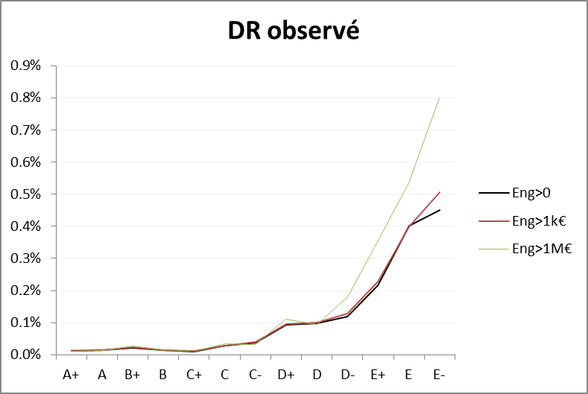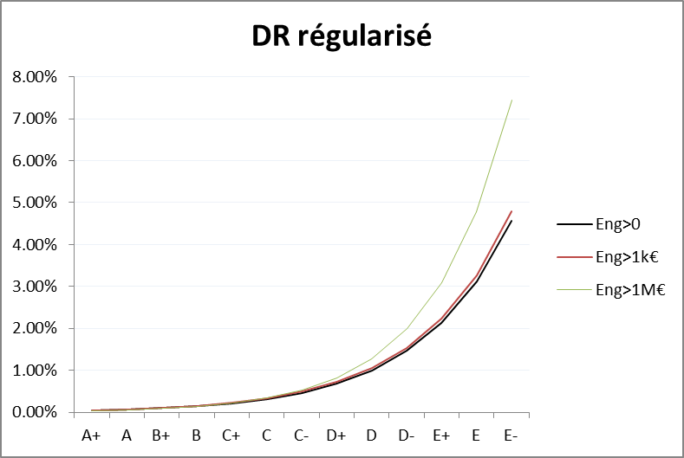

1. The engagement filter does not modify the dynamic of the default rate.



For these reasons, an exposition filter of 1M€ is used.

### Segmentation

The choice made by CACIB is to segment risk profiles as deep as data availability could allow it.

Empirical observations of point in time matrices segmented by ratings, counterparty nature and geographical area lead to a poor number of events (migrations or defaults). This is why the segmentations were tested in the following order.

1. Counterparty nature X Continent
2. Counterparty nature group (Corporate, Financial Institutions, Sovereigns) X Continents
3. Counterparty nature group (Corporate, Financial Institutions, Sovereigns) X Countries grouped by Emerging and Non-Emerging
4. Counterparty nature group (Corporate, Financial Institutions, Sovereigns, SME) with no segmentation on geographical area
5. No segmentation

This order is set giving priority to the nature then the geographical area. This is justified by the dominance of multinational groups in CACIB portfolio.

**Segmentation 4 is selected without a proper Sovereign and SME segments. Sovereigns are included in Financial Institution calibration whereas SME and retail are mapped to corporate segment.** This choice is justified below:

Why choosing segmentation 4?

The tables below show the lack of data for a segmentation by rating, nature (Corporate vs Financial Institutions) and geographical area (Investment grade, Non-Investment Grade). This evidence doesn’t allow for further segmentation. This is the balance between precision and availability of information.







Table 1: Number of cells with no observations in the PIT migration matrix. The more migration matrix is segmented the more null cells are observed.

Furthermore, segmentation 4 is widely shared in the literature (See STAMP€ ECB [1] p.45 for example).

Why including Sovereign into Financial Institutions segment?

Sovereigns’ provision is not material in CACIB portfolio (<1.5 %).The modeling effort is proportional to the materiality. This measurement is a conclusion based on the following facts:

* As of 31/12/2017, the Sovereign Forward Looking impairment is equal to 1.5% of the total CACIB impairment. The calculation is done using financial institutions calibration in place of proper Sovereign calibration.
* Evidence show that Sovereigns are less risky than financial institutions (See Figure 1). The impairment measurement leading to 1.5% is therefore an over-estimation.

Empirical observations show that using financial institutions calibration for Sovereigns is conservative (See Figure 1 as evidence that PIT default rates are lower for sovereigns than financial institutions).

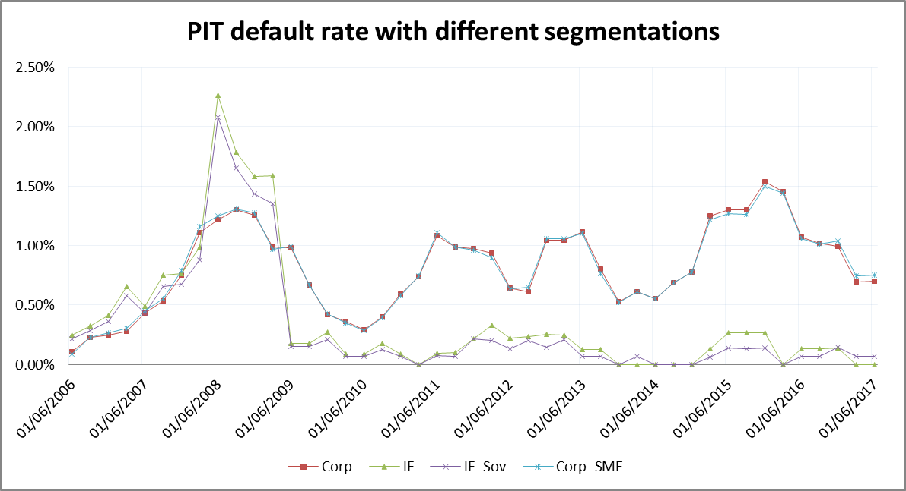

Figure 1: PIT Default Rate. IF_Sov is a joined calibration between financial institutions and sovereigns and corp_sme is a joined calibration between corporate and small and medium enterprises.

Why mapping SME and retail to large corporate segment?

CA-CIB portfolio includes mainly large corporate companies. SME and retail are non-material subsets; therefore no segmentation is done using the size of the company.

* **SME**: Figure 1 shows the similarity of 1Y PIT default rate including or excluding SME. Their inclusion is not significant; they will be mapped to corporate segment.
* **Retail:** Retail in CA-CIB portfolio is limited to private banking. For confidentiality purposes, counterparties are aggregated in pools. This makes their migration unobservable in the internal database. In order to avoid having these aggregated counterparties bias the matrix construction, they are filtered from the study. They are mapped to corporate segment.

# Matrix regularization methodology

Observed transition matrix rates could reveal sometimes irregularities, lack of monotony following rows or columns. This section aims at describing motivations, methodology and the impact of matrix regularization.

## Motivation

### Definition of a regular transition matrix

Consider a rating scale where 1 is the best rating and is the default state.

Given a Transition Matrix, let’s denote its coordinates. They represent the probability for an issuer rated at the start date to migrate to rating on the final date. The coordinates of a transition matrix are expected to have the following regularities:

1. Ratings represent a qualitative assessment of the credit risk quality; the better the rating the lower the default probability is. This condition is called default vector monotony and could be formalized as the following:
2. The default state is an absorbent state, no migration from the default to a non-default state is possible. Otherwise, all migrations from state in to a state in are probable.
3. Issuers have a higher probability of migrating to a nearer state than to a farther state. This condition is called rows monotony and could be formalized as the following:
4. Issuers have a higher probability of having migrated from a nearer state to the present one than from a farther state. This condition is called columns monotony and could be formalized as the following:

### Example or irregular observed matrices

Here below is an example of annual matrices based on observed internal data.







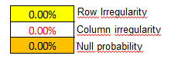

### Evidence of statistical incertitude

The aim of this sub section is to demonstrate that:

1. The estimation incertitude is the main cause of the lack of monotony by comparing the confidence level to the irregularities
2. A regularization process is statistically viable

The number of transitions on a given line could be modeled – without any assumption – as a multinomial probability distribution. The historical observations are a stochastic realization and could be framed in confidence intervals.

Example of transitions on rating A+

The following graphic illustrates the lack of monotony in A+ observed migration to the other ratings along with the confidence intervals (sup and inf).

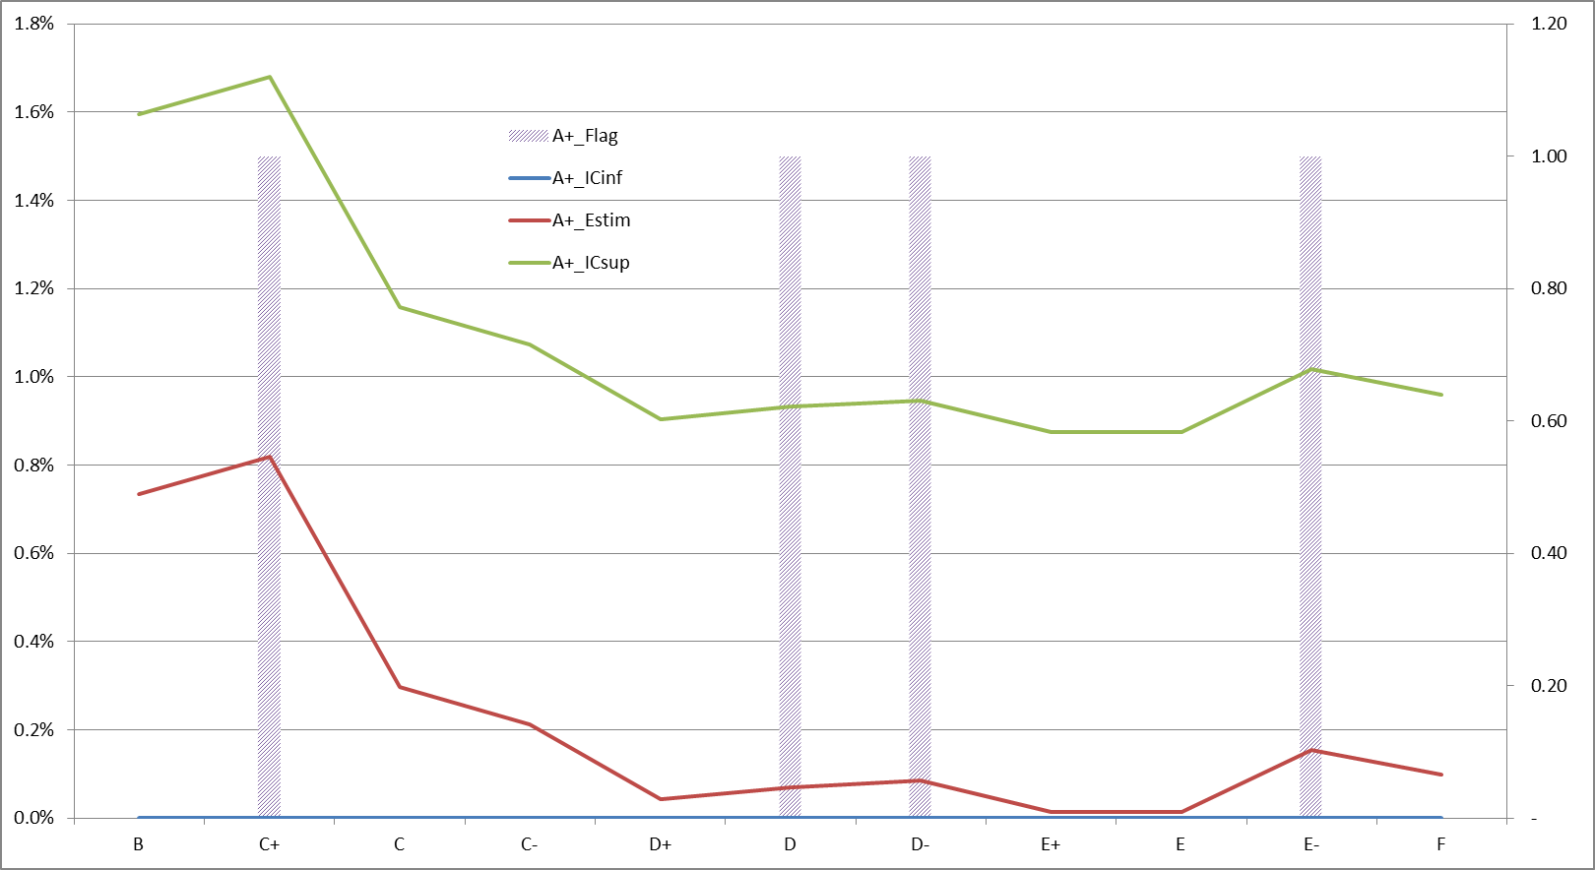

The main findings of this graphic are:

1. The lack of monotony (illustrated by the flags), are non-significant compared to the confidence intervals, this suggests that estimation incertitude is the main cause of the irregularities.
2. One could imagine a regular (monotonic) solution within the confidence interval. This makes a regularization process statistically viable.

Sensitivity study

This study shows the impact of adding 1 observation on the matrix rates.

Initial:



Adding 1 observation:



Results: (Example A+/A+ = 82.81% vs 82.96% = -0.2%)



Findings:

1. Some matrix coordinates are significantly sensitive to 1 observation. This leads to high estimation incertitude

Default vector example

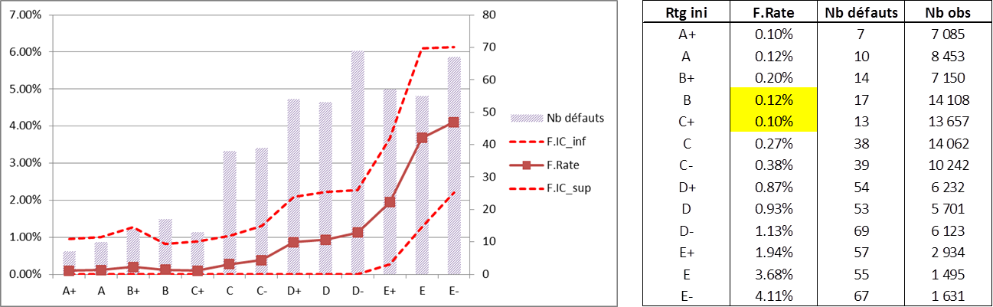

The main findings of this graphic are:

1. The lack of monotony (illustrated by the flags), are non-significant compared to the confidence intervals, this suggests that estimation incertitude is the main cause of the irregularities.
2. One could imagine a regular (monotonic) solution within the confidence interval. This makes a regularization process statistically viable.

## Methodology description

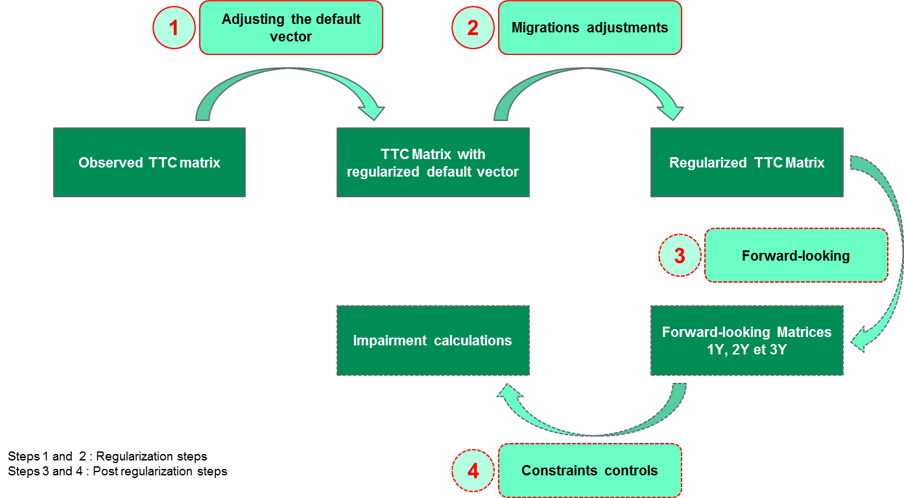

Figure 2: Overview of the regularization principle

Tested approaches

1. A local smoothing approach was tested. The principle is to spot the lack of monotony, for example between B+ and D+, and exponentially smooth between these two points.

Pros:

* + Part of the observations remain unchanged from the observation
  + Simplicity

Cons:

* + It is subject to a judgment: which are the legitimate points and which are regular points? The graphic below shows that the impact of this judgment is significant
  + The method force to ignore observations considered as not legitimate. Note that each point is an aggregation of numerous observations of survival and defaults.
  + The method cannot be automated

1. Global exponential smoothing on the whole vector.

Pros:

* + It is not subject to any judgment
  + Can be automated

Cons:

* + It does not take into account the number of observations on each point and is sensitive to adding 1 observation to a migration

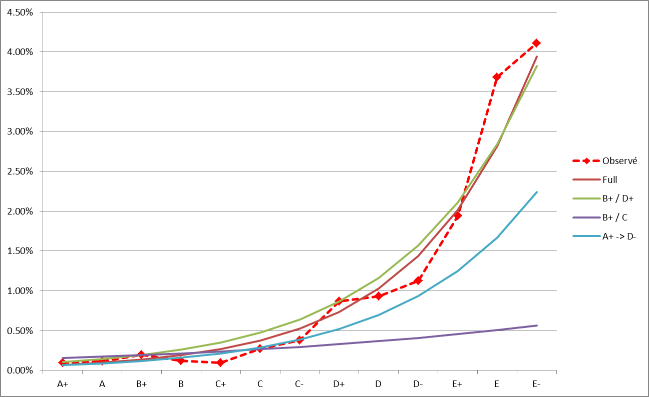

### Default vector regularization

Used approach

One could model each observation of {Default / Survival} as a Bernoulli distribution, by assuming that the issuers are independent and identically distributed. The rating Bernoulli parameters are .

Let’s denote , the number of surviving issuers rated on the initial date and the number of defaulting issuers on the final date. The empirical (or observed) default rate is given by .

It follows that for each rating , is deterministic and follows a Binomial distribution .

The methodology is basically a calibration of by likelihood maximization subject to the constraints:

1. Strict positivity:
2. Strict increasing:
3. Global DR unchanged:

Note that, when constraints 1 and 2 are met, the empirical default rates are the solution.

In order to model the constraint, an exponential shape () is used because it fits both constraints and the likelihood function is concave, allowing for global unique maxima.

Let’s shape as the following:

Constraint 3 links directly with and observed defaults.

Therefore are given by:

Result example

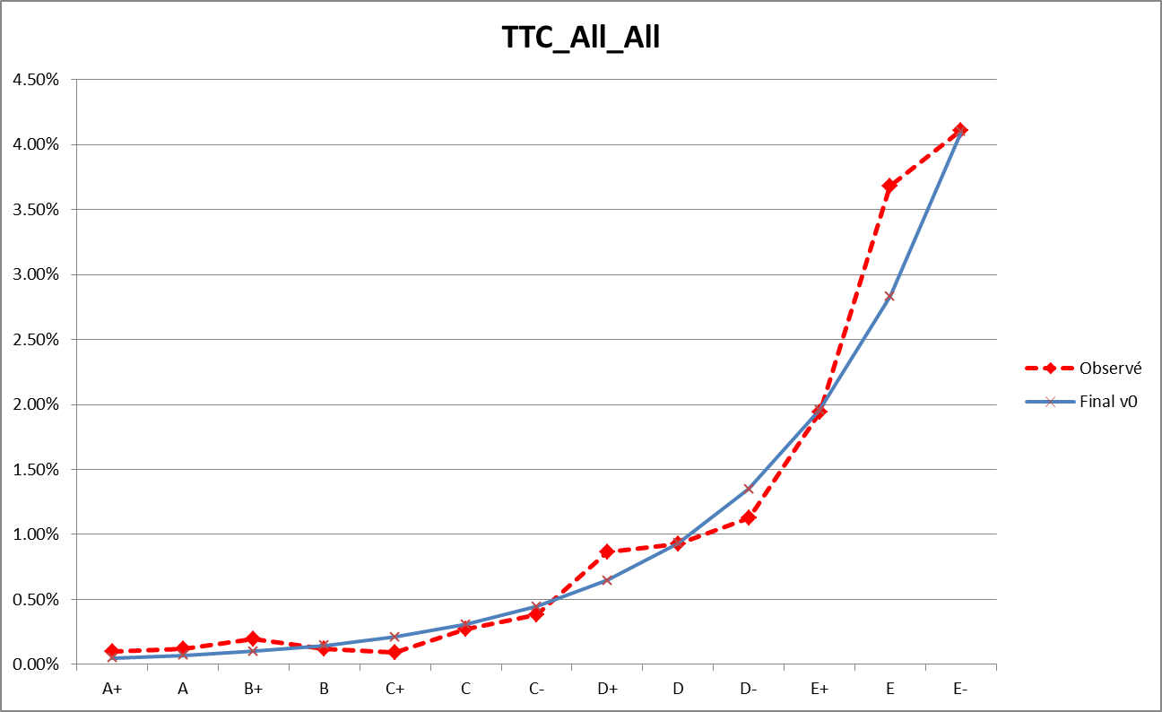



### Migration probability regularization

Used approach

Let’s denote the number of observed migrations from to . Consequently, and .

Each row is regularized separately. For each initial rating , one could assume that issuers are i.i.d and model the numbers of observed migrations as a multinomial distribution with parameters .

The method is a parallel calibration of each for each subject to the following constraints:

* Strictly decreasing from the diagonal
* Strict positivity , for each and
* Maintaining the probability of default on each rating: is obtained in step 1
* For each rating, maintaining the overall probabilities of upgrade and downgrade. This leads naturally to unchanged diagonal

In order to fit the constraints, the following exponential shape is used.

The likelihood of the multinomial distribution is given by

The parameters are retrieved from likelihood maximization.

## Results and Impacts

Results illustration

The graphics below illustrate example of regular solutions. Note the proximity with the observed rates and the statistical viability of the solutions continuously limited by the confidence intervals.

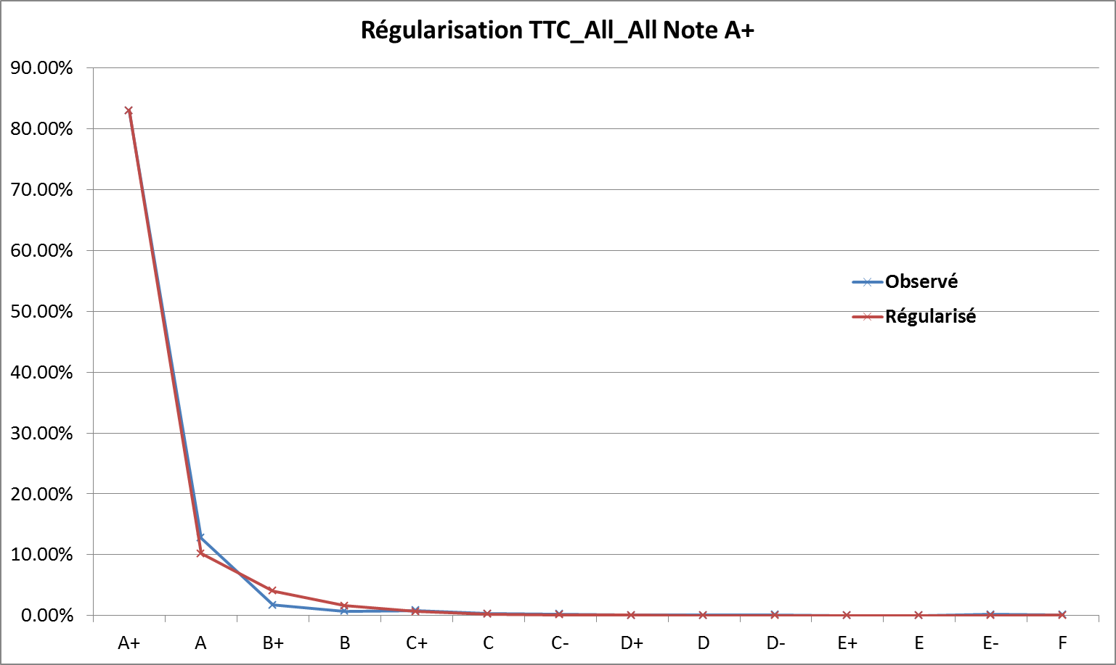

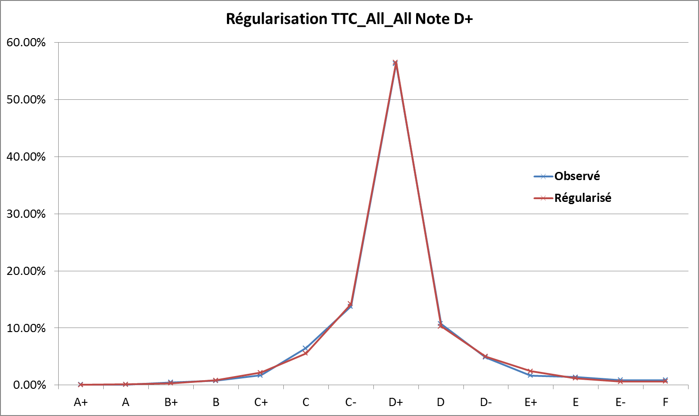

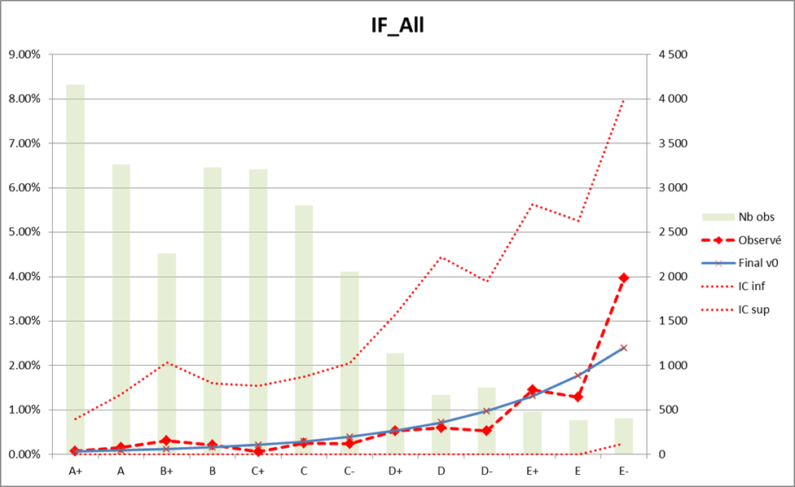

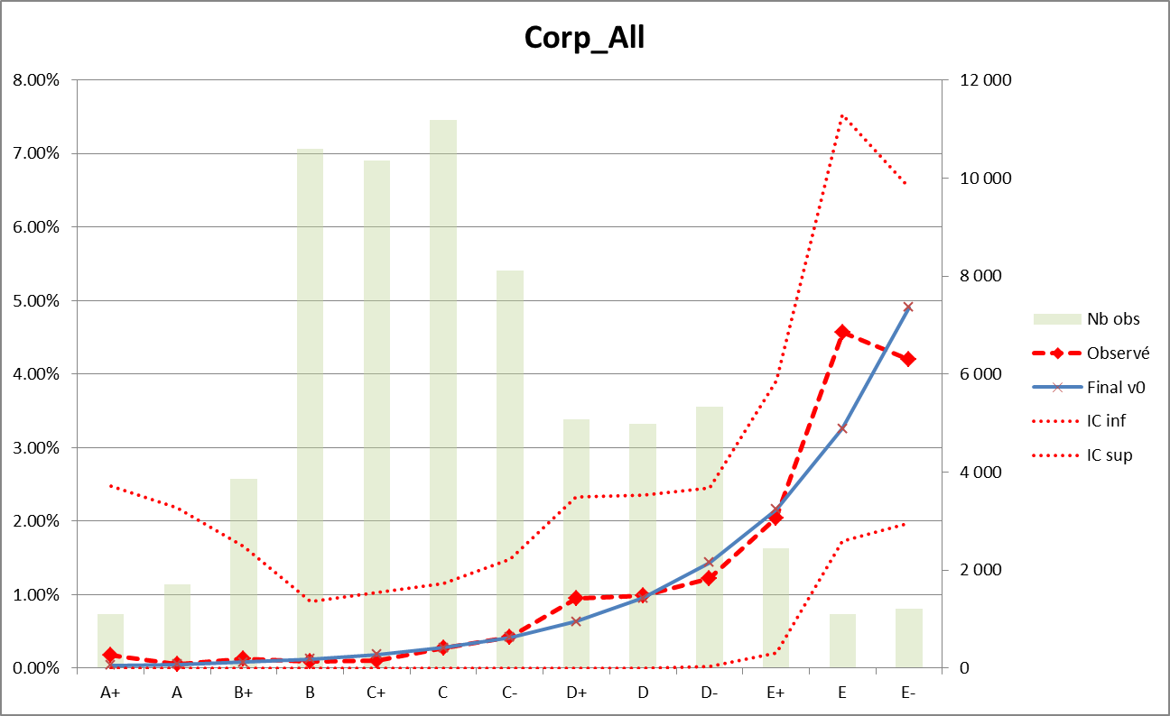

Impact measurement

The aim of this subsection is to compare how far the regularized matrix goes from the initially observed transition matrix. Distance matrix and eigenvalues based indicators are been used to measure the impact of the regularization.

The following distance formulas are found in the literature, see [2] and [3]. They represent different interpretations ranging from Euclidian distance, to measures based on the eigenvalues (trace, determinant, sum of eigenvalues, second largest eigenvalue as it has been linked to the economic cycle).

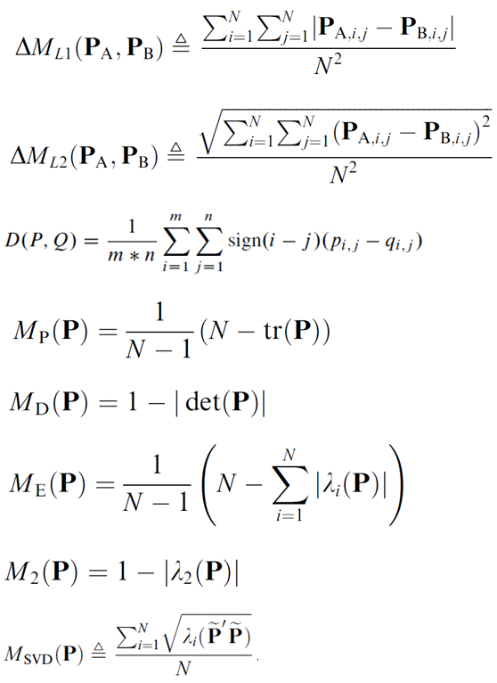

Measures based on matrix eigenvalues

Distances between 2 matrices

Interpreting the closeness of the regularized matrix to the observed matrix is not straightforward since the absolute levels given by these indicators do not allow for direct interpretations. However, it relevant to compare the distance between the TTC regularized matrix and the TTC observed matrix with:

* the distance between the TTC observed matrix and each PIT observed matrix
* the distance between the TTC observed matrix and each TTC observed matrix calibrated on the whole historical depth minus 1 year

The table below shows the distance indicators (ML1, ML2, MDEX, MTRU) between the TTCini (initially observed matrix) and the other matrices (2010 means the 2010 PiT matrix and TTCreg means the regularized TTC matrix); along with the eigenvalues based indicators. The graphics below represent the same. Other graphics on IF / Corp and S&P are shown in the appendix; they lead to the same conclusion.



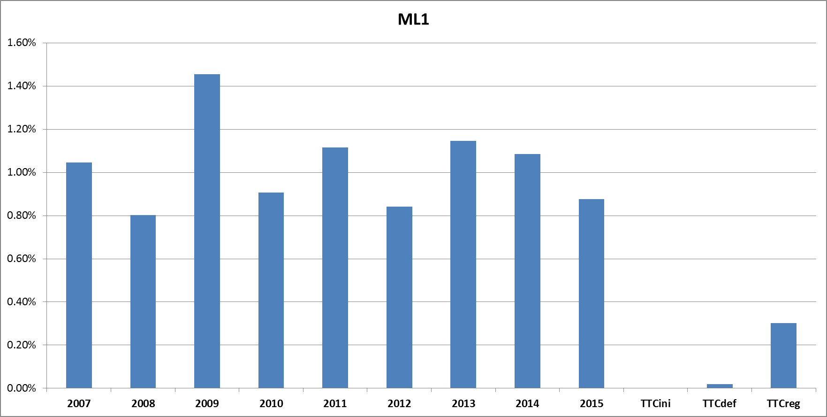 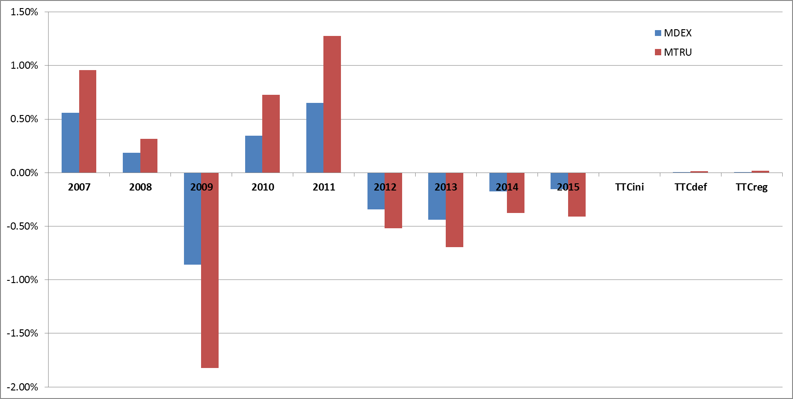

**The metrics prove that the TTC observed matrix is closer to the regularized matrix than any PIT matrix.**

**Conclusion:** The overall regularization process is an alternative calibration of the transition matrix. The solution is regular, statistically viable and the impacts are non-significant.

# Term structure default probability

The process above describes the way to retrieve a regular TTC 1Y migration matrix. The 1Y cumulated default probability for each rating denoted is red in the default column of the matrix .

TTC term structure default probability is defined using a homogeneous Markov Chain assumption, according to the group CASA methodology guidelines. Under this assumption, it is demonstrated that the TTC n-years migration matrix is given by raising the TTC 1Y migration matrix to the power n.

Again, the n-years cumulated default probability for rating is red in the default column of the n-years matrix.

Note the following desirable features of the model:

* Using a regular matrix raised to the power leads to a cumulated default probability surface strictly increasing on both dimensions: Rating and Maturity. This is a desirable feature for a cumulated default probability model.
* The homogeneous assumption is specific to the fact that the desired matrix is TTC. If the model were to be adjusted to the economic cycle in a stressed or forward looking context, the 1-year TTC matrices could be replaced by adjusted matrices. A cumulative product will replace the raise to power and would give rise to stressed / forward looking cumulative default probability surface. The homogeneous Markov Chain assumption would then be weakened to a non-homogeneous Markov Chain assumption.

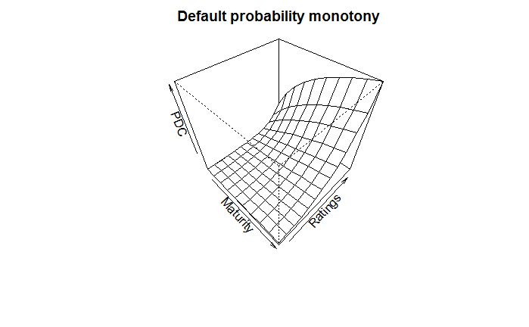

Figure 3: Corporate TTC term structure default probability. Note strict increasing along with both axes

# Appendix

## Regularization impacts

S&P data base

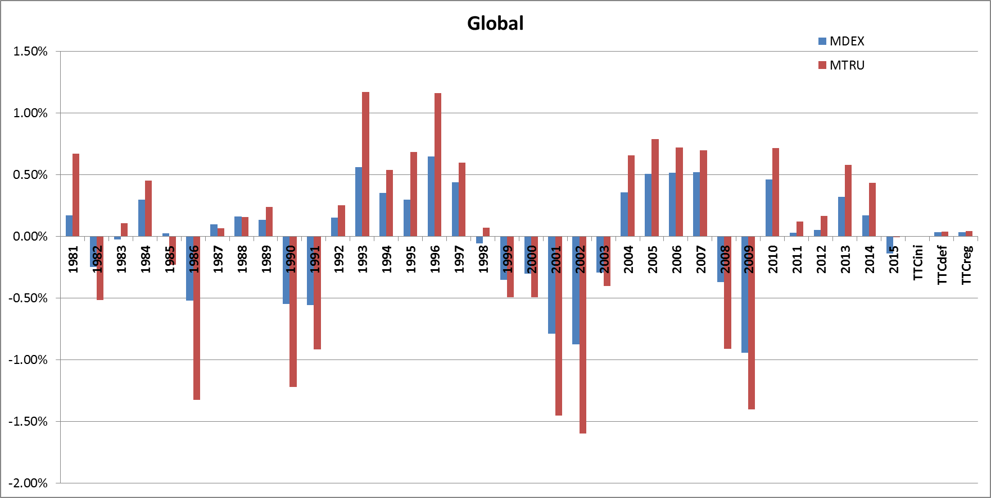

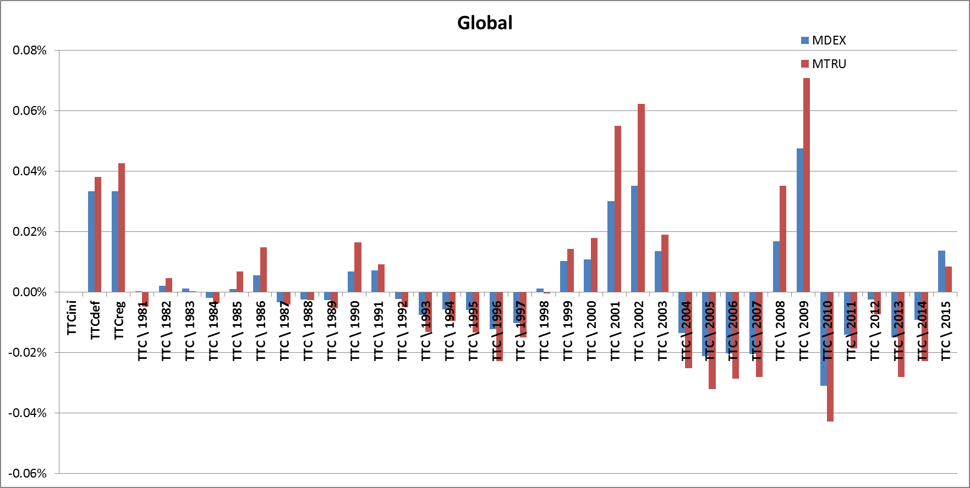

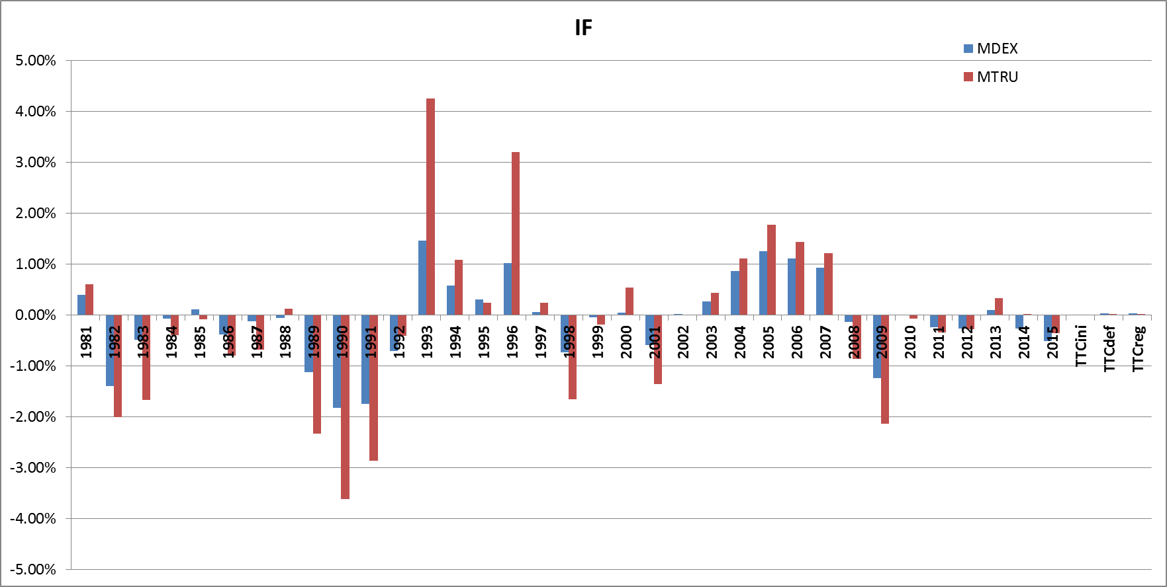

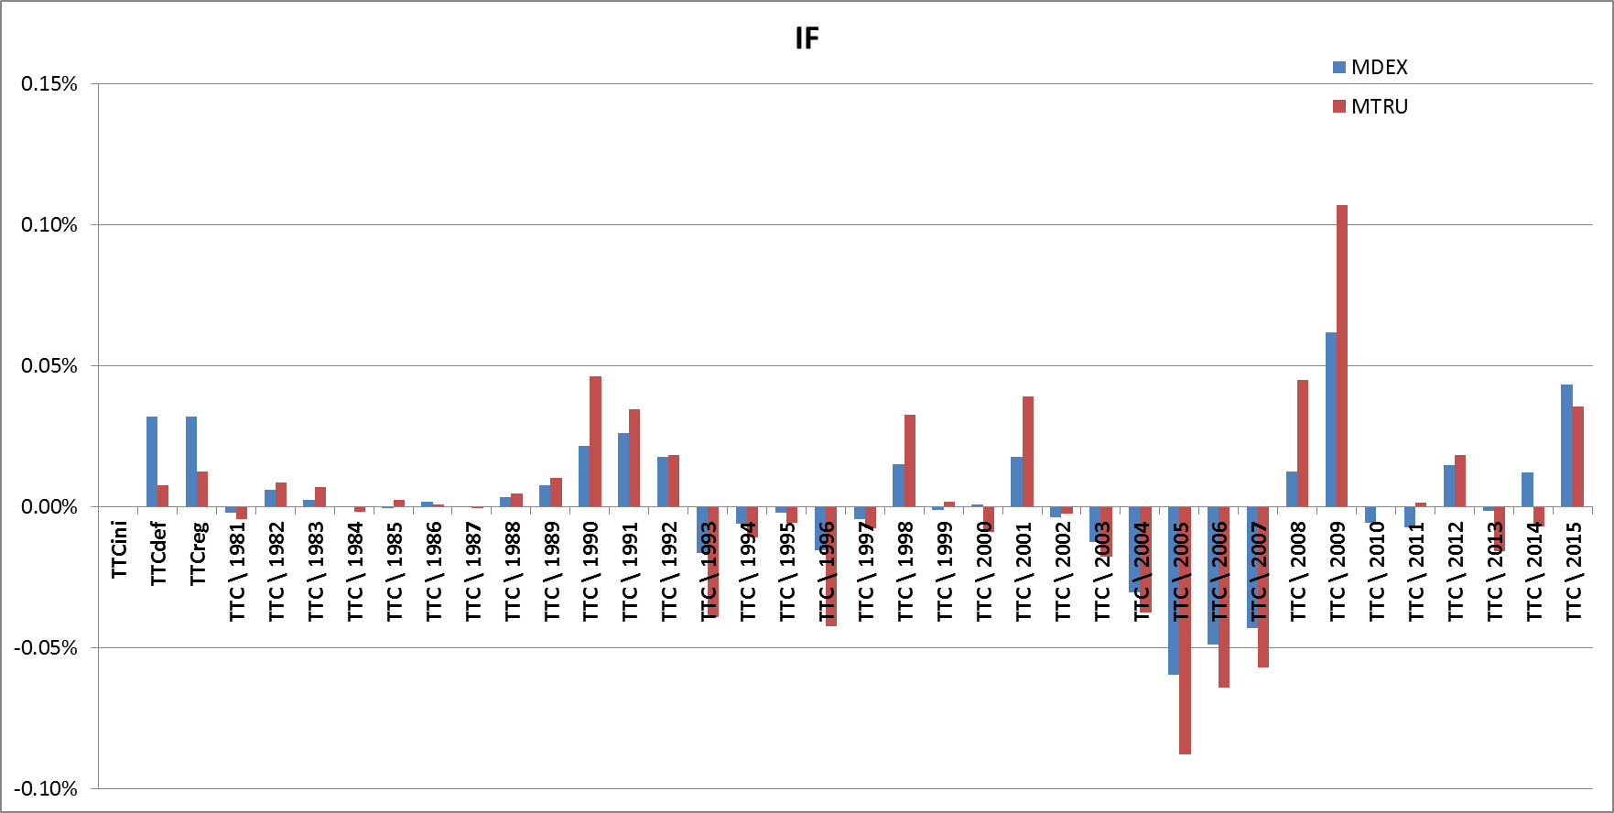

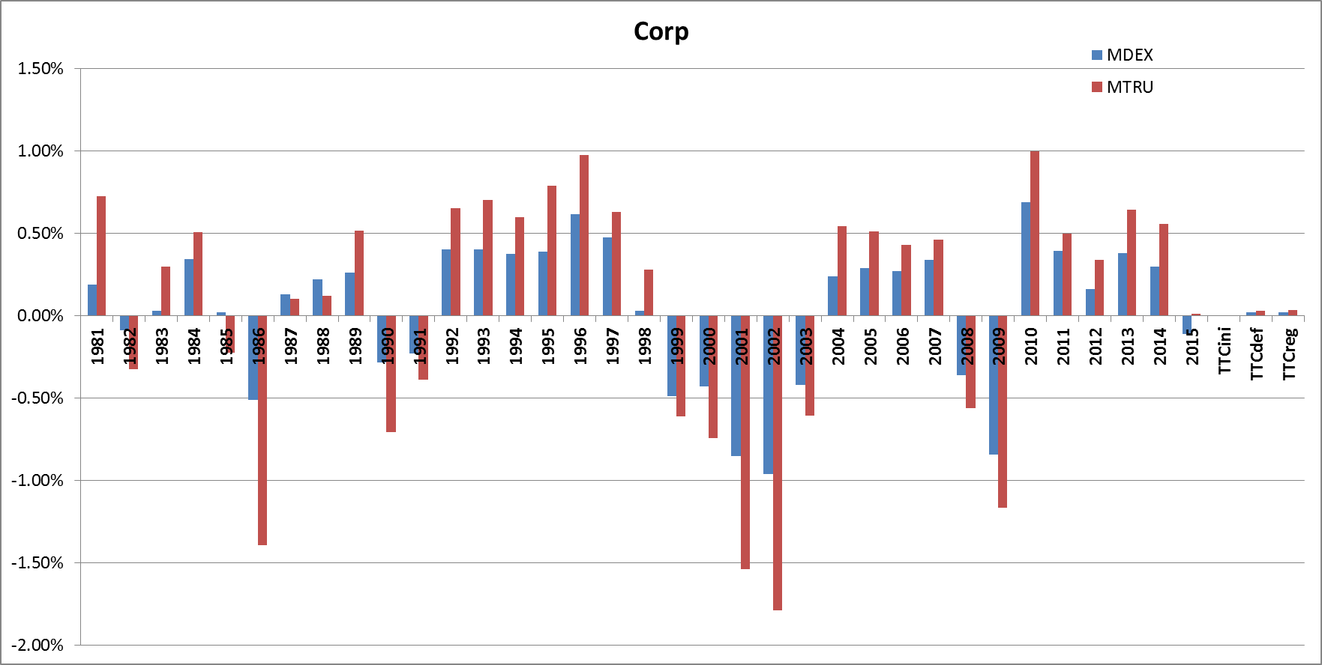

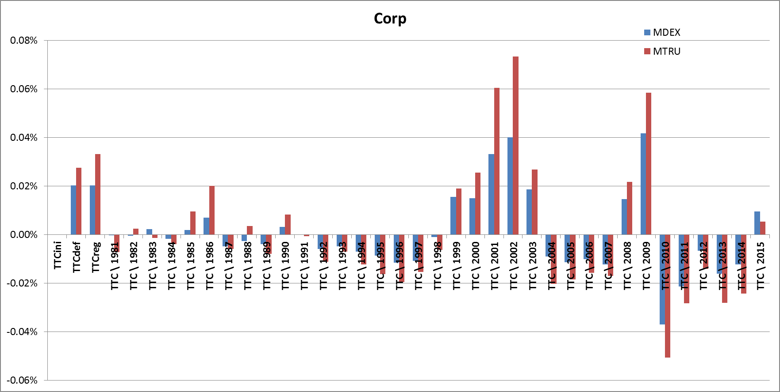

# Bibliography

|  |  |
| --- | --- |
| [1] | J. H. a. R. M. Stéphane Dees, "STAMP€: Stress-Test Analytics for Macroprudential Purposes in the euro area," European Central Bank, 2017. |
| [2] | T. S. Yusuf Jafry, "Measurement, estimation and comparison of credit migration matrices," *Journal of Banking & Finance,* pp. 2603-2639, 2004. |
| [3] | T. S. Yusuf Jafry, "Metrics for Comparing Credit Migration Matrices," *Wharton Financial Institutions Center Working Paper No. 03-09,* 2003. |
| [4] | S. C. I. R. Solutions, "CreditPro Methodology," *McGRAW-HILL FINANCIAL,* 2015. |